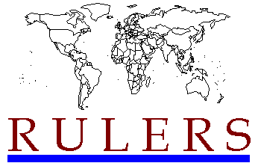

|  |
| --- |
| **WORLD STATESMEN.org** |



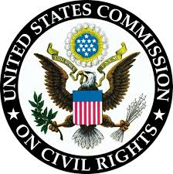

**List of Chairpersons, 1958–present**[[edit](https://en.wikipedia.org/w/index.php?title=United_States_Commission_on_Civil_Rights&action=edit&section=6)]

* John A. Hannah, 1958–1969
* Theodore Hesburgh, 1969–1972[[23]](https://en.wikipedia.org/wiki/United_States_Commission_on_Civil_Rights#cite_note-23)
* J. Stephen Horn, 1972–1974 (Acting)[[24]](https://en.wikipedia.org/wiki/United_States_Commission_on_Civil_Rights#cite_note-24)
* Arthur S. Flemming, 1974–1981[[25]](https://en.wikipedia.org/wiki/United_States_Commission_on_Civil_Rights#cite_note-25)
* Clarence M. Pendleton Jr., 1981–1988[[26]](https://en.wikipedia.org/wiki/United_States_Commission_on_Civil_Rights#cite_note-26)
* William B. Allen, 1988–1989[[27]](https://en.wikipedia.org/wiki/United_States_Commission_on_Civil_Rights#cite_note-27)
* Arthur Fletcher, 1990–1993[[28]](https://en.wikipedia.org/wiki/United_States_Commission_on_Civil_Rights#cite_note-28)
* Mary Frances Berry, 1993–2004
* Gerald A. Reynolds, 2004–2011
* Martin R. Castro, 2011–2016
* Catherine E. Lhamon, 2016–2021
* Norma V. Cantu, 2021–2023
* Rochelle Garza, 2023–present

United statescommission on civil rights